***University of Missouri-Kansas City***

***Subject- Network Routing***

***CPLEX project***

***Submitted to:***

***Dr. Deep Medhi (Network Routing Professor)***

***Submitted by:***

***MIHIR PITALE (16252203)***

4.2) a) The optimized flow to free maximum capacity is given below-

Code-

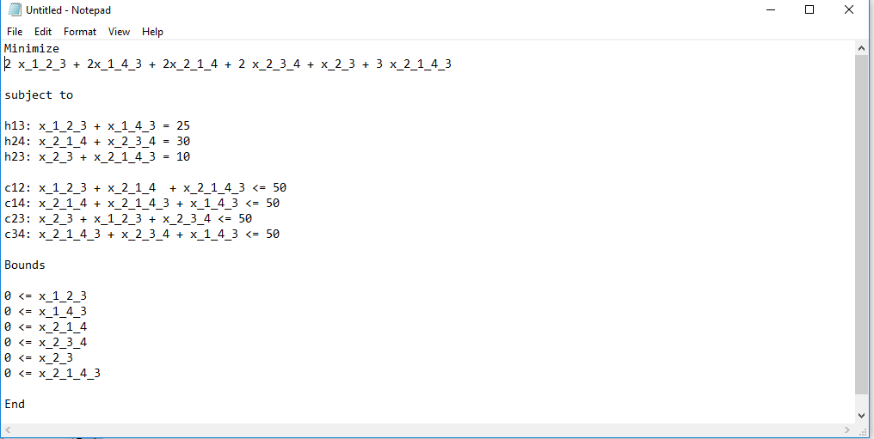

Output-

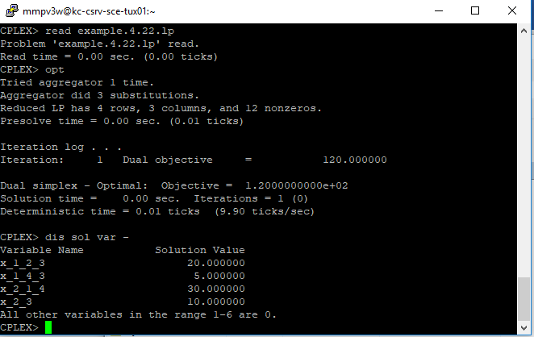

4.2) b) optimal flow for load balancing the network is as follows-

Code-

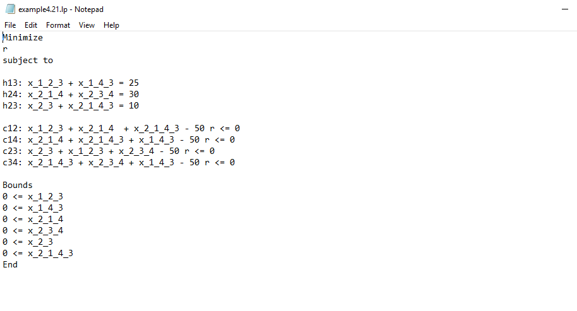

Output-

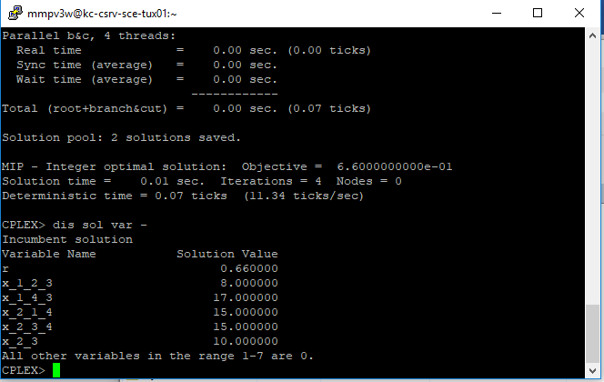

4.2) c) The demand volume for each demand pair must not be split into two paths

Code-

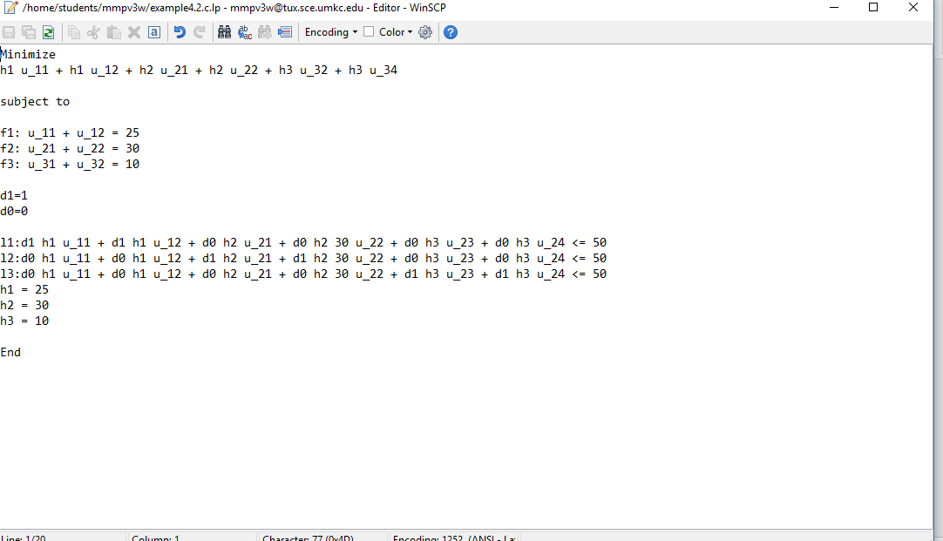

Output-

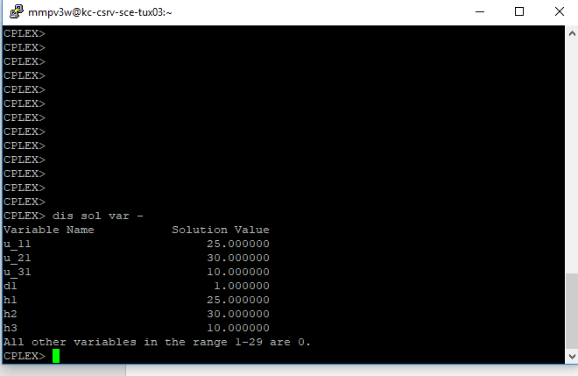

4.4) a)1) single demand between node 1 and node 9 is considered with volume 60. Finding optimal flow by using link costs we get,

c12 = 100,

c14 = 100,

c23 = 100,

c25 = 100,

c36 = 100,

c45 = 100,

c56 = 100,

c47 = 100,

c58 = 100,

c69 = 100,

c78 = 100,

c89 = 100

Code-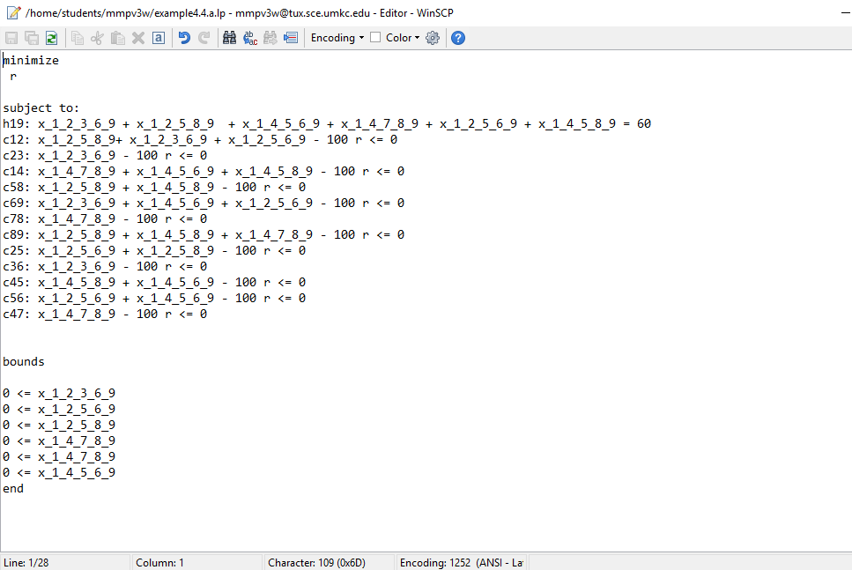

Output-

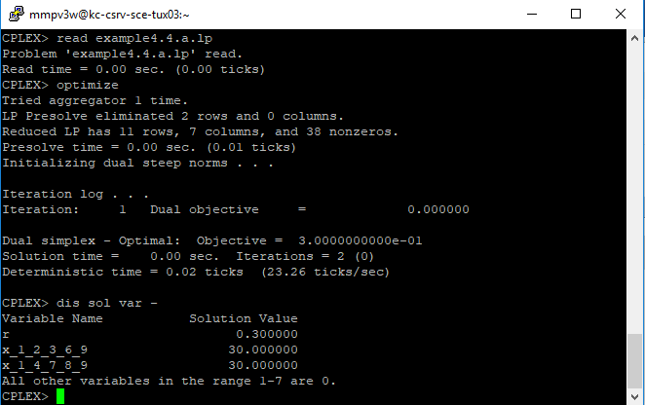

4.4) a2) If two demands, one between 1 and 9 and another between 3 and 7, each of volume 60, considered

Code-

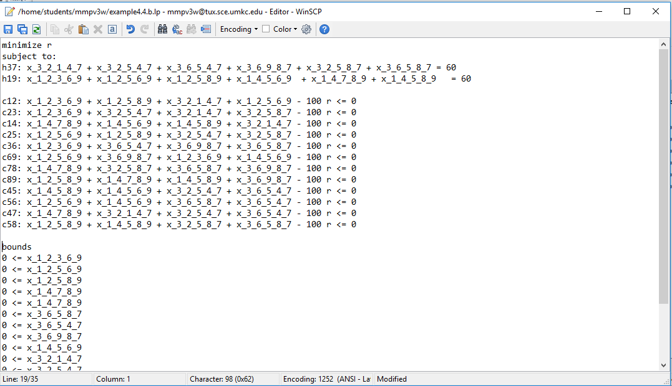

Output-

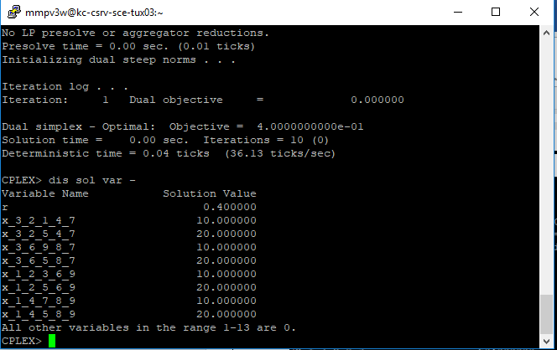

4.4)b1) All links have 100 units of capacity except for links 2-5, 4-5, 5-6, 5-8, which have 60 units of capacity. Now, Single demand between node 1 and 9 with volume of 60 units is considered.

Code-

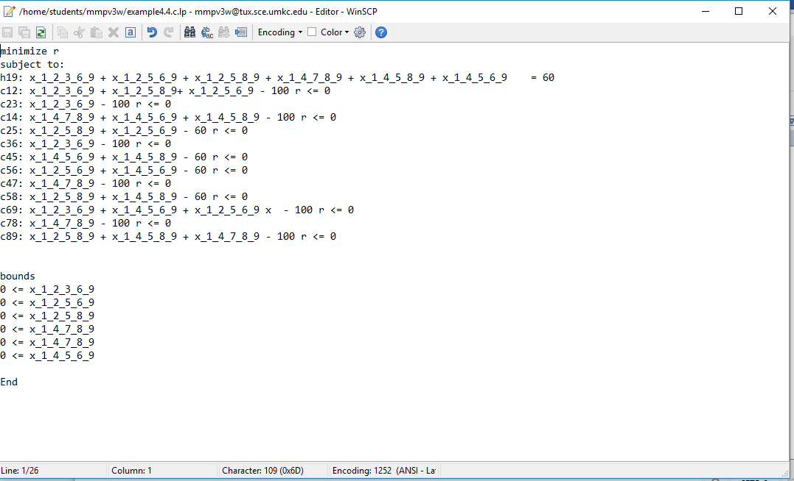

Output-

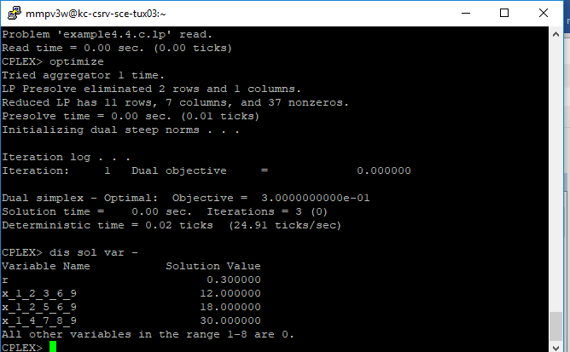

4.4) b2) Now If two demands, one each between 1 and 9 and another between 3 and 7, each of volume 60, are considered.

Code-

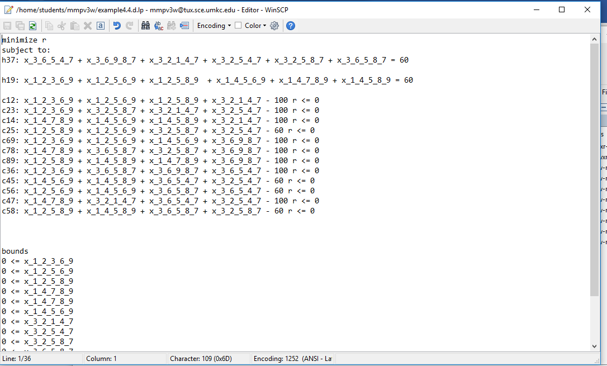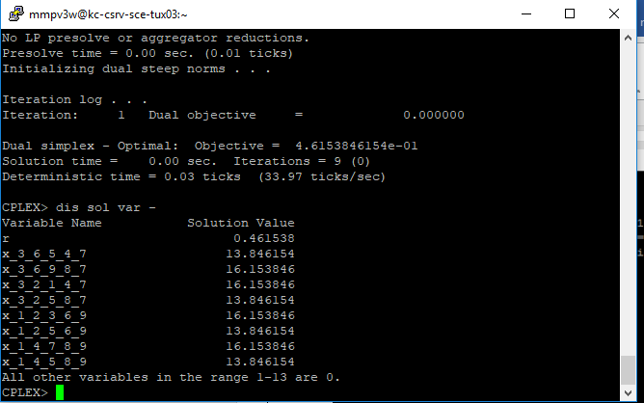

7.2) a) load balancing optimization

**a)** Load balancing optimization

**Link capacities** are given as follows;

* 30 on link1-3,
* 10 on link 2-4,
* 10 on link 3-4
* 5 on link 1-4,
* 15 on link 2-3

**Demand volumes** are given as;

* 15 for pair 1:2,
* 20 for pair 1:3,
* 10 for pair 2:3

Code-

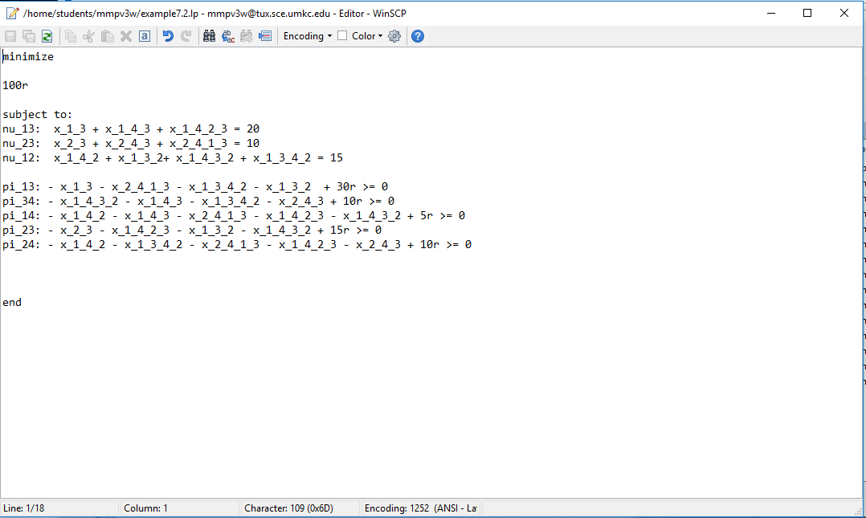

Output-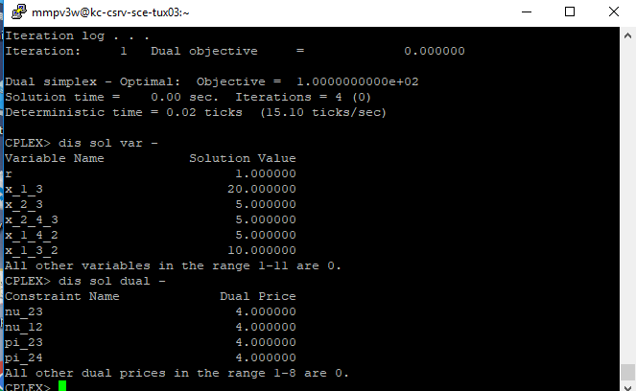

7.2) b) Solving the composite solution for the above problem we get,

We multiply links by number of hops and get the solution as follows,

Code-

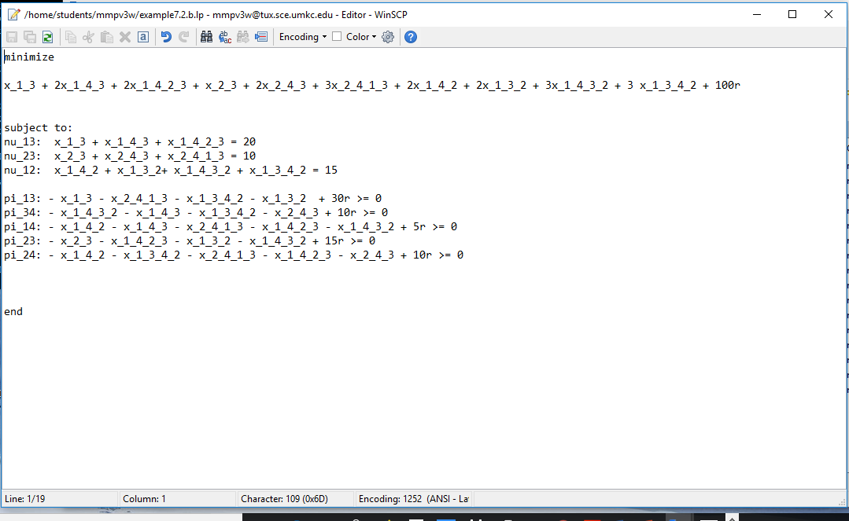

Output-

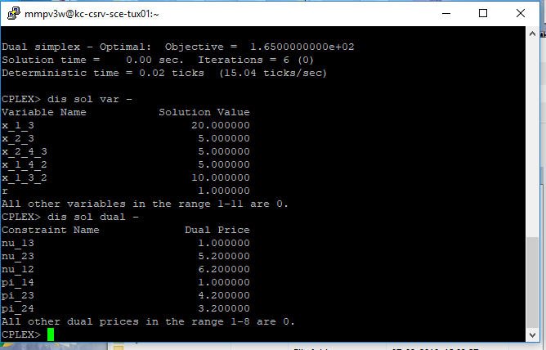

7.4) a1) finding the link weights by using Dis Sol dual –

We get,

single demand between node 1 and node 9 is considered with volume 60.

c12 = 100,

c14 = 100,

c23 = 100,

c25 = 100,

c36 = 100,

c45 = 100,

c56 = 100,

c47 = 100,

c58 = 100,

c69 = 100,

c78 = 100,

c89 = 100

Code-

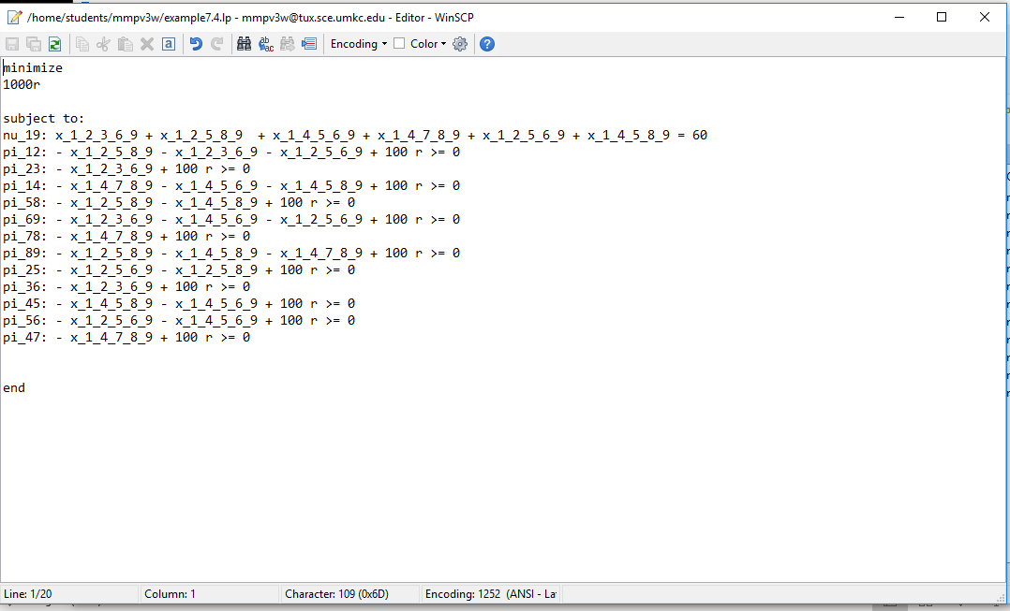

Output-

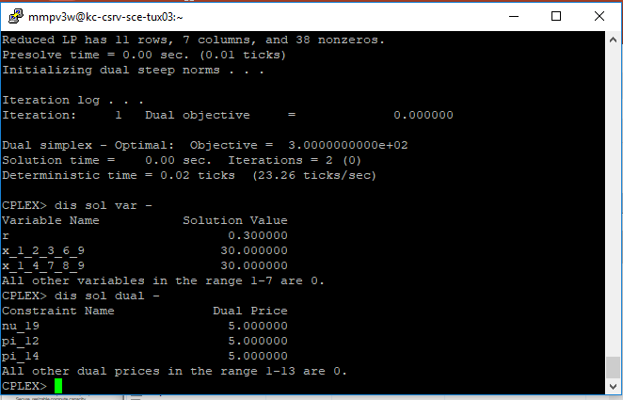

7.4) a2) If two demands, one between 1 and 9 and another between 3 and 7, each of volume 60, considered

Code-

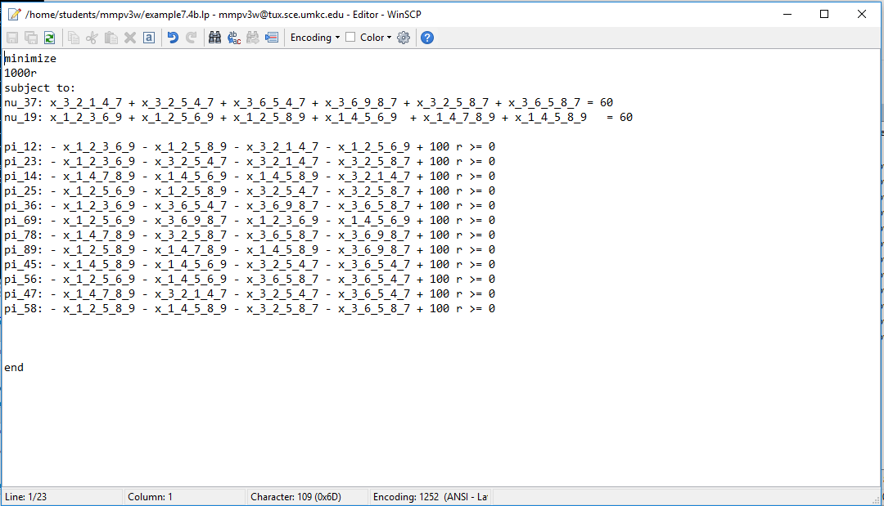

Output-

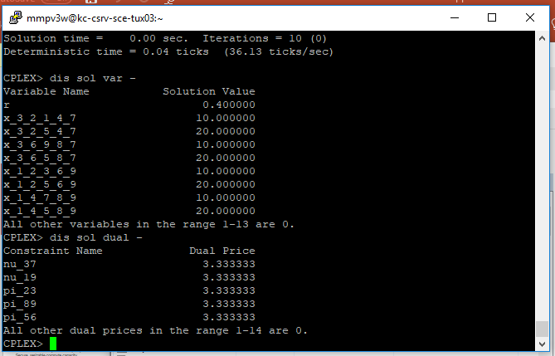

7.4) B1) All links have 100 units of capacity except for links 2-5, 4-5, 5-6, 5-8, which have 60 units of capacity. Now, Single demand between node 1 and 9 with volume of 60 units is considered. Now finding for link weights we get,

Code-

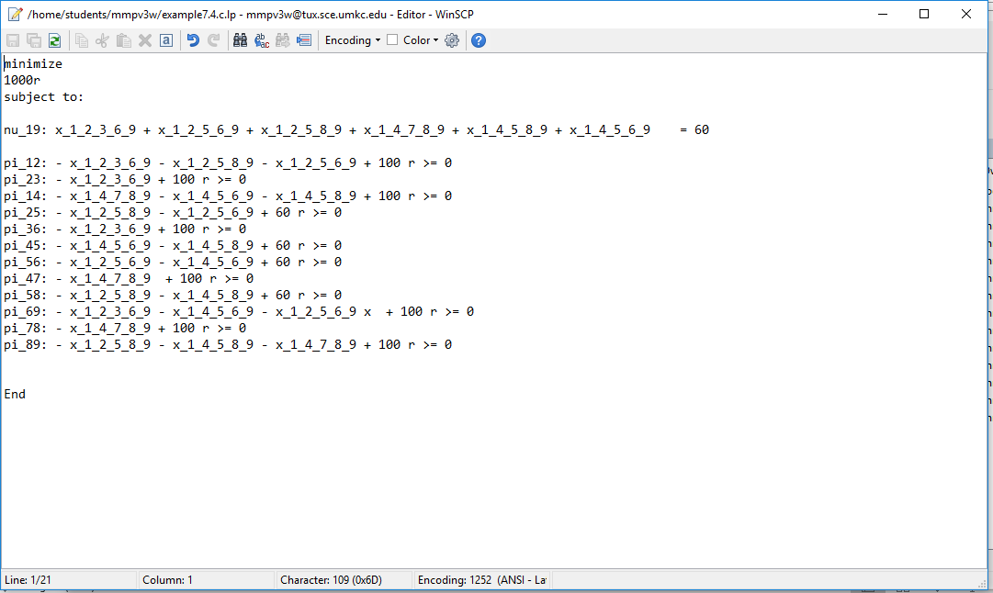

Output-

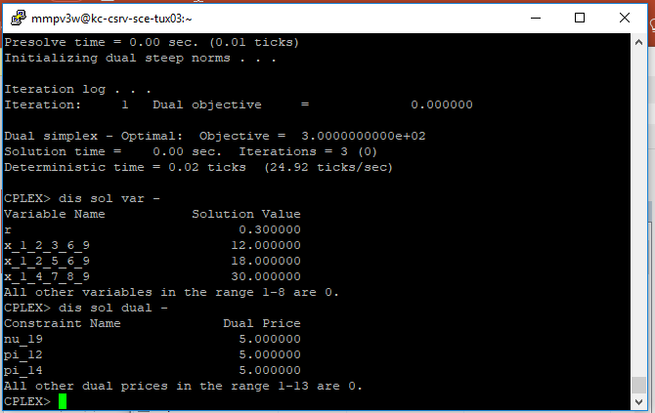

7.4) b2) Now If two demands, one each between 1 and 9 and another between 3 and 7, each of volume 60, are considered. Then finding by link weights we get

Code-

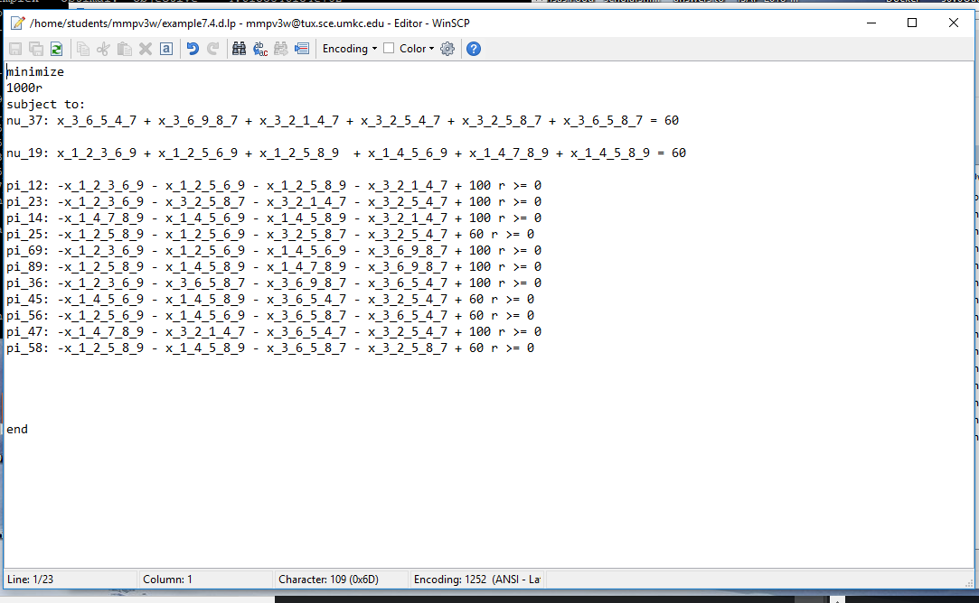

Output-

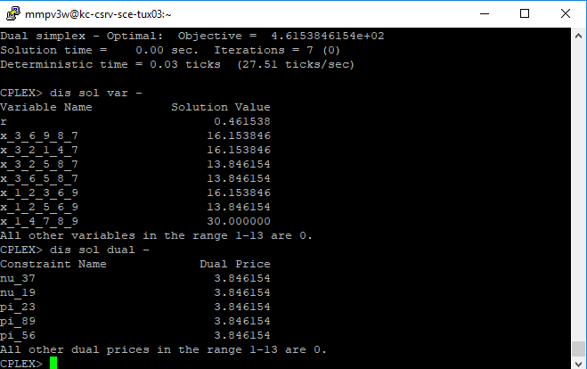

------------------------------------------x----0----x------------------------------------------------------